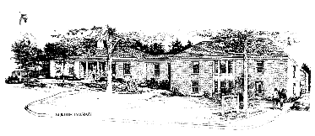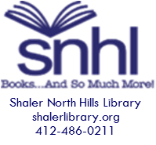

***Shaler North Hills Library***

**Memorial and Honor Book Program**

 A memorial or honor gift to the Shaler North Hills Library is one that “keeps on giving”. Your gift will enable the library to purchase books and materials in memory of, or in honor, of relatives, friends or a special occasion. The materials we purchase reach thousands of people. A library book, given as a memorial or in honor of a celebration, is a fitting and lasting tribute that continues a person’s­ impact on the community.

**How may I contribute to this valuable program?**

* Please use the form below. You may type directly in the form, or download and print it to complete. You may mail it, drop off with a staff member, or type, re-save, and email to: [shalerref@einetwork.net](mailto:shalerref@einetwork.net).
* Checks should be made payable to: *Shaler North Hills Library*. You may use the ‘DONATE” button on our website—please indicate “Memorial/Honor” program in the notes. The minimum contribution for a memorial/honor gift is $25.00.

* A letter of acknowledgment or appreciation will be sent to both the donor and the family of the  
  honoree.
* If preferred, choose an area of interest: adults, teens, or children.
* The memorial book will bear a personalized book plate naming the donor and honoree. Ask us about bookplate designs or how you can add a photo to the design.
* Books that are donated to the library may not necessarily be added to the collection as memorial or honor books. Please check with the Library Director before doing so. Sometimes the library may already have the book or it may not be the newest edition of a title.

* The library purchases new and current items for the collection. The process could take up to 2-3 months for selection if we are waiting for a newly published item.

***Thank you so much for your donation and consideration of this valuable program.***

***Shaler North Hills Library***

**Memorial and Honor Book Program**

I wish to make a donation in honor of/in memory of or to celebrate a special occasion.

Please clearly print the name of the person you are recognizing:

|  |
| --- |
|  |

Is this:

In memory of

In honor of

In celebration of an occasion: ____________________________

Is this:

A one-time gift An ongoing monthly gift

|  |  |
| --- | --- |
| Amount of donation: |  |

|  |
| --- |
| Please include any additional wording you wish for the bookplate: |
|  |

Please indicate which area we should purchase materials from:

Adult Materials Teen/Young Adult Materials Children’s Materials Library Choice

Whom should we notify of your gift?

|  |  |
| --- | --- |
| Name: | |
| Address: | |
| Phone: | Email: |

Your contact information:

|  |  |
| --- | --- |
| Name: | |
| Address: | |
| Phone: | Email: |

LIBRARY USE ONLY

|  |  |  |
| --- | --- | --- |
| Payment Type | Date | Processed |
|  |  |  |